**Emergency Ventilator**

General description

Issue/change record

|  |  |  |  |
| --- | --- | --- | --- |
| Issue | Date | Author | Reason of issue/summary |
| 0.A | 10/04/2020 |  | DRAFT, released for ongoing development |
|  |  |  |  |
|  |  |  |  |
|  |  |  |  |
|  |  |  |  |
|  |  |  |  |

Contents

1 General description 3

1.1 Device 3

1.2 Intended use 3

1.3 Expected service life 4

1.4 Combination devices 4

1.4.1 Required combination devices 4

1.4.2 Recommended combination devices 5

1.4.3 System level arrangement 6

1.4.4 Incompatibility 6

1.5 Performance characteristics 7

1.6 Comparable devices 9

1.6.1 Respironics Trilogy 202 (without volume module) 10

1.6.2 SLE2000 infant ventilator 10

1.7 MDR classification 10

1.8 User responsibility 10

2 Device application context 11

# General description

## Device

The device is a ventilator intended for providing mass intensive respiratory care, in facilities that might be lacking in full hospital infrastructure, abundant oxygen supplies and clinical experiences – such as under pandemic emergency conditions.

The ventilator is designed for a simplified clinical protocol that demands minimal training and re-training. It is further designed to be mass-producible and requiring minimal maintenance. The gas cycling operation is designed to minimise oxygen consumption.

The ventilator operates in conventional Pressure Controlled SIMV (Synchronised Intermittent Mandatory Ventilation) mode of ventilation only. It interfaces with intubated, unconscious and semi-conscious, patients; and it interfaces with pressure ventilation masks on conscious patients. There is no need to select and switch between alternative modes or interfaces.

SIMV behaves as PSV (Pressure Support Ventilation) when the patient makes full efforts, and it behaves as CMV (Continuous Mandatory Ventilation) if the patient does not make any efforts. When used with a mask on a conscious, spontaneously breathing patient, the SIMV behaves as nPSV or Synchronised BiPAP (by setting IP low). Switching the IP cycle off (or setting it equal to PEEP) makes SIMV behaves as CPAP (whether the patient is intubated or has a mask interface).

For purpose of simplicity, the I:E ratio (Inspiratory-Expiratory) is fixed 1:2. Inspiration flow rate fixed 60L/min, which produces an IP rise time of about 0.45s into a 600mL lung.

The device is not intended to be marketed as a commercial medical device. The device conforms to medical device requirements for basic safety and essential performance. There is not, yet, any basis for proving the clinical efficacy of the device.

The ventilator is designed to operate in combination with an external power supply, a breathing circuit and a respiratory gas humidifier (HME or water chamber).

## Intended use

Mechanical ventilation is indicated when the patient's spontaneous breathing is inadequate to maintain life. In general, mechanical ventilation is used to support the correct blood gases and reduce the work of breathing. Mechanical ventilation provide assistance for breathing. It does not in itself treat the patients underlying disease.

The ventilator is intended for use with adult and young adult patients from 50kg and upwards. It interfaces with intubated, unconscious and semi-conscious, patients; and it interfaces with pressure ventilation masks on conscious patients.

The ventilator is designed for a simplified clinical protocol that demands minimal training and re-training. It is further designed to be mass-producible and requiring minimal maintenance. The gas cycling operation is designed to minimise oxygen consumption.

The general operating environment are hospitals and temporary healthcare facilities. Although the device is suitable for intra-hospital transport (moving patient between hospital departments, while being ventilated), it is not classed as a transport device. It is not designed for road or air transport.

The device is not intended to be marketed as a commercial medical device. The device conforms to medical device requirements for basic safety and essential performance. There is not, yet, any basis for proving the clinical efficacy of the device.

## Expected service life

The ventilator has a product life of 8 years from the date of manufacture. This excludes the main battery, which has an approximate 4-year life.

Solenoid valves should be replaced with new or overhauled valves every 10,000 hours, or every 2 years of regular use.

Apart from the battery, the ventilator and accessories do not contain any special hazardous components. No special precautions are required for their disposal. The device should be disposed of in accordance to the local WEEE (Waste Electrical and Electronic Equipment) guidelines.

At the end of its useful life this battery should be disposed of in accordance with local authority guidelines.

## Combination devices

### Required combination devices

#### Power supply unit

The ventilator receives electrical power from an external power supply. Under the definitions for medical electrical equipment (standard IEC 60601-1), the ventilators forms part of a mains power connected Medical Electrical System (MES). The ventilator itself is not a mains connected Medical Electrical Equipment (MEE). The power supply unit must therefore conform to national standards for MEE (e.g. it should have CE or national equivalent mark). The power cord must be attached to the ventilator, using a P-clip, to prevent accidental disconnection.

#### Exhalation valve

The ventilator ‘Gas Return’ port receives common exhalation valve components, of the pressure diaphragm type such as Intersurgical stock codes 1922500 (exhalation valve); 1977000 (T-connector); and 1950000 (directional valve). Equivalent valves from other manufacturers are available, but might require an adaptor for secure fitting to the ventilator.

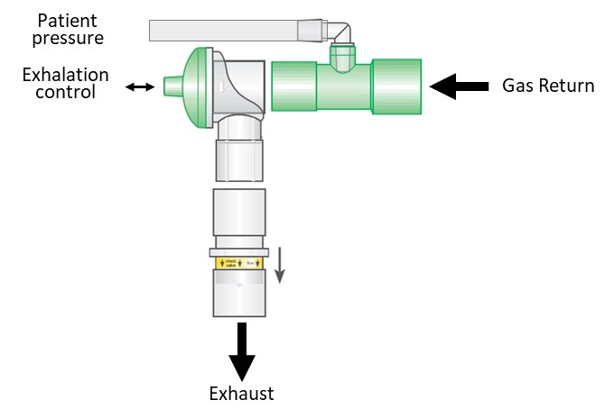

#### Ventilator breathing circuit

The 22mm breathing circuit should meet medical device standards, including conformity to ISO 5356-1 for conical connectors. The simplest configuration of breathing circuit is preferred. The breathing circuit must have a maximum compliance of 5ml/mbar (or 5ml/cmH2O) and a maximum resistance of 1mbar (or 1 cmH2O) at 30L/min flow rate. These values are met by most available 22mm circuits in the market.

The breathing circuit interfaces with the patient’s airway via an endo tracheal tube or a sealed mask (not an open or venting mask). When using a mask in the treatment of infectious diseases, it is preferred to channel the exhaled gas away from the patient, as opposed to exhausting directly into the ambient patient environment.

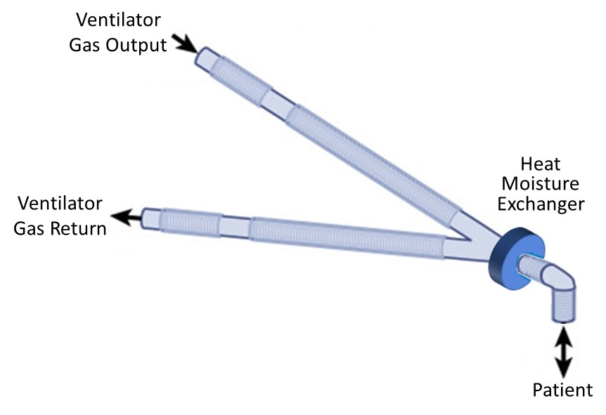

#### Humidification

When ventilating an intubated patient, the circuit should as minimum contain an HME (Heat Moisture Exchange) device placed at the patient interface.

Alternatively, the HME may be replaced by introducing a water bath or ultrasonic humidifier on the ‘Gas Output’ side of the breathing circuit. This should normally be matched by a water trap on the ‘Gas Return’ side of the circuit, to collect the moisture that otherwise collects inside the tubes.

### Recommended combination devices

#### Blood CO2 measurement device

CO2 elimination is a primary measure of ventilation efficiency. A fixed installed or portable TcCO2 or EtCO2 measurement device would meet this monitoring need EtCO2 correlates directly to blood CO2). Alternatively, CO2 levels can be measured by blood tests.

#### Blood O2 measurement device

O2 saturation is a second sought outcome of assisted ventilation. A fixed installed or portable SpO2 measurement device (e.g. finger pulseoximeter) would meet this monitoring need.

#### Other vital signs

Although exclusively related to the outcome of assisted ventilation, other the monitoring of general vital signs are also important – including heart rate, blood pressure and patient temperature. Ventilation may influence these parameters.

#### Bacteria filter

It is recommended to fit a bacteria filter on the exhaust port, when the patient has an infectious disease.

### System level arrangement

The system level here illustrates a 10-bed ward. This configuration is scalable to many more beds, in extended or parallel arrangements. The ventilators stand on bedside tables. The ventilators receive pre-blended gas, from one of optional supply lines. This arrangement significantly simplifies the ventilator design.

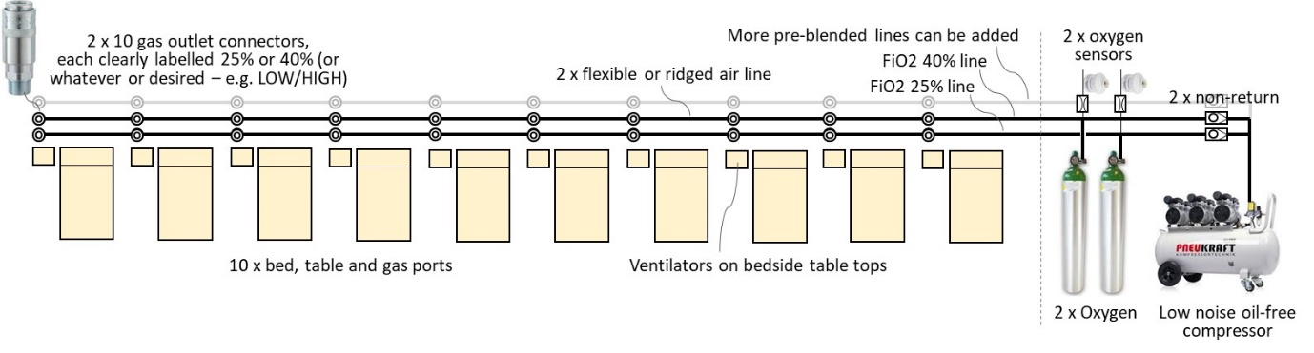

The example here shows 2 parallel gas lines, supplying pre-blended 25% and 40% FiO2 (finally inspired oxygen concentration) respectively. The FiO2 settings can be changed to whatever clinicians prescribe. For example, the pair of lines supplying a group of 10 severely compromised patients might be set differently (say, to 30% and 50%) to a different pair of lines supplying a group of lesser compromised patients (say, 21% and 30%). The 2 lines could also be extended to 3 or 4, in areas where the needs demand it.

The FiO2 concentration in the supply lines is adjusted by regulating the oxygen supply pressure from the bottles. The concentration is monitored using simple oxygen cell technology. The monitor will signal if the FiO2 level drifts, say when several patients are switched to the alternative line. This will require a technician attending to the lines and adjusting the oxygen bottle regulator, until the target FiO2 is met (+/-3% v/v).

### Incompatibility

The ventilator is not designed to be compatible for the strong magnetic fields that exists inside an MRI scanner control zone.

The ventilator is not compatible with a gas driven nebulizer – i.e. the type that adds a gas flow to the breathing circuit. Note: the ventilator is compatible with an ultrasonic nebulizer or other type that does not add an extra gas flow to the breathing circuit.

## Performance characteristics

* Interfaces with intubated, unconscious and semi-conscious, patients; and interfaces with pressure ventilation masks on conscious patients.
* 22mm patient circuit, using commonly available components (no bespoke circuit component). The ventilator presents 22mm ‘male’ fresh gas port and 22mm ‘female’ on the exhalation valve. Single-use is preferable, with minimal reusable parts – e.g. a disposable single-use exhalation value that is supplied pre-assembled onto the patient circuit is preferred.
* Exhalation exhaust port is standard 22mm connector, enabling bacterial filter or gas scavenging to reduce the risk of cross-contamination (see Section 3 for optional disinfector concept).
* HME (Heat Moisture Exchange) device is used at the patient interface.
  + Optionally, the ICU can elect to use a medical gas humidifier (heat or ultrasound actuated), if one is available and preferred; but this is not the default low tech, low skill design solution (mal-adjusted humidifiers in the hands of non-experts can ‘drown’ a patient).
* Directional non-return valves at each end of the patient circuit, to allow ambient air supply for the patient’s spontaneous breathing under gas supply or ventilator failure conditions.
* Pressure Controlled SIMV (Synchronised Intermittent Mandatory Ventilation) mode of ventilation only. No need to select and switch between alternative modes. SIMV behaves as PSV (Pressure Support Ventilation) when the patient makes efforts, and it behaves as CMV (Continuous Mandatory Ventilation) if the patient does not make any efforts. When used with a mask on a consciously breathing patient, the SIMV behaves as Synchronised BiPAP. Switching the PIP cycle off (or setting it equal to PEEP) makes SIMV behave as CPAP (whether the patient is intubated or has a mask interface).
* Breath detection by pressure change algorithm (not flow sensor or nerve activity).
* Maintains steady PEEP level and PIP plateau under mask leak conditions.
* PEEP/EP (Peak End Expiration Pressure), between 4 mbar and 25 mbar, adjustable in 1 mbar steps (1 mbar = 1.02 cmH2O and the 2 units can be considered practically equal).
* PIP/IP (Peak Inspiration Pressure), between 4 mbar to 35 mbar, adjustable in 1 mbar steps.
* Patient circuit pressure is limited to maximum 40 mbar under ventilator failure conditions. Reliable failsafe prevents any single failure mode from resulting in compressed supply gas reaching the patient.
* BPM (Breath Per Minute) rate 10 to 30, in steps of 1. This can be increased to 40 is desired.
* I:E ratio (Inspiratory-Expiratory) fixed 1:2.
* Inspiration flow rate fixed 60L/min (producing an IP rise time of about 0.45s into a 600mL lung).
* Does not incorporate a gas blender. The makeshift ward should instead have 2 or more supply lines with pre-blended gas (say, FiO2 25% and 40%), which the clinicians can elect to plug into. The process for switching from one supply line to another during patient ventilation, will require that a lung recruitment manoeuvre is performed (e.g. 2 seconds manual breath) immediately after switching – to assure optimum CO2 elimination.
  + Optionally, if a blender is required, then Section 3 describes a low tech mechanical (non-electrical) solution, which can be added. This could be added to the outside (or inside) of the ventilator, for those special cases that needs an FiO2 21% to 100% setting that differs to the pre-blended options.
* Supply gas pressure 2 to 7 bar (pressure regulator must ideally withstand 7 bars, but compromise to 5 bar is possible where the compressor output is assured to max 5 bar).
* Industry standard gas connectors. Uses a single gas supply to ventilator, with the hose continuously connected at the ventilator end. Air-Oxygen differentiation is therefore not required. Any industry standard quick release pneumatic connector can be used, but it must be the same consistent standard across the care ward.
* 110V to 240V, 50Hz to 60Hz mains power. Integrated 45 minutes backup battery power (when using 2.1Ahr battery).
* Indicator lights visible at more than 3 metres distance:
  + Red flashing light when an alarm condition exists (this could be made tricolour).
  + Green light flashes once for 0.5s when a breath is detected.
* Audible alarm, with IEC60601 standard priority ‘melody’ (high, medium, low).
* Alarms messages in LCD displays for:
  + Monitor error (high priority, detected and reported by controller sub unit).
  + Controller error (high priority, detected and reported by monitor sub unit).
  + Gas supply failure (high priority).
  + Battery low (high priority).
  + Patient circuit disconnect (high priority).
  + Patient circuit overpressure shut down (high priority).
  + Set PEEP not achieved +/- 2mbar (medium priority).
  + Set PIP not achieved +/- 3 mbar (medium priority).
  + PIP rise time not achieved (medium priority).
  + Expiration decay time too long (medium priority).
  + Mains power loss (low priority, switch to battery power).
  + Patient circuit leak (information only message, flashing up for 1 sec every 3 sec).
* Monitor display:
  + Trigger Rate – as the percentage of delivered breaths that were initiated by the patient. This is a measure of patient efforts and consciousness (progress or deterioration).
  + Tdi, the PIP rise time – indicator of lung compliance, but also if gas supply pressure fails.
  + Tde, expiration wave decay time – indicator of the bacterial filter or patient circuit being soiled (excessively resistive) and need replacing. Where a small resistance is added to the exhaust (i.e. bacteria filter) the Tde can also help indicate lung obstruction (fluids, puss).

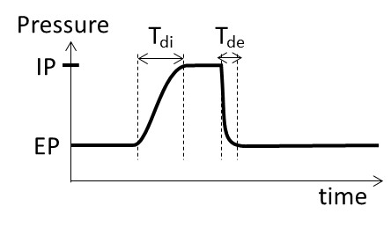

* Maximised use of off-the-shelf components that are readily available in a national supply chain.
* The type of components all have prior use in respiratory ventilators and can be assumed to have an acceptable RF and EM compatibility profile. The emergency situation does not afford time for extensive EMC testing.
* Tolerant to alternative components use – e.g. can use 2.4mm orifice solenoid valve from one brand or 3.0mm orifice solenoid valve from another brand – including a mix of different sizes. Simply adjust the pressure regulator to suit (to achieve the standard PIP rise time).
* All components in the gas pathway are oxygen resistant and free from obnoxious/infectious materials. For example, the regulator and solenoid valves do not have any oil residues from their manufacturing process. Pre-cleaning might be an option.
* Enclosure:
  + Metal construction.
  + Bottom vent holes, as required to evacuate any oxygen leak (heavier than air), to prevent a combustion hazard.
  + Bottom and downward-facing louvre vents, so that water poured on top of device will not ingress to the internal electrical components.
  + Surfaces are smooth/polished and free from crevasse that might harbour germs, for easy cleaning.
* Desktop mounted, with 4 rubber feet.
* Design to be developed and validated to ‘acceptable’ standards in 1 week.
* Design to be produced and tested at a high rate by a low skilled workforce, supervised by someone skilled in the medical device precautionary processes. Each ventilator must be approved/signed off by an individual that is competent in assessing the impact of ventilator performance on a patient.
* User instructions in a detailed training and service manual, and an A4 laminated quick guide.
* Packaging for containment, preservation and cleanliness during transport t.b.d.

## Comparable devices

Pressure Control ventilation is a well-known therapy dating back more than 50 years. Practically all marketed advanced ventilator feature Pressure Control modes of ventilation, with volume control entirely disengaged, matching the functionality of the present ventilator.

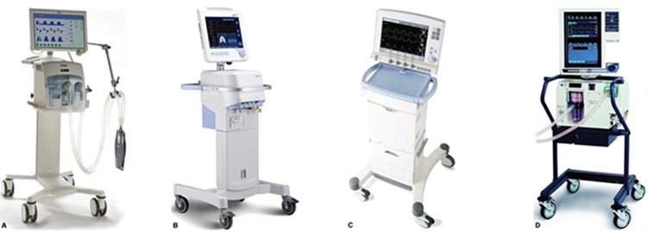

Examples of leading advanced ventilators that feature Pressure Control modes of ventilation. These advanced ventilators operate with or without volume monitoring. The advanced ventilators of course also feature Volume Control and combination modes, which are above the function of the present ventilator.

Examples of exclusively Pressure Controlled SIMV ventilators in the market includes:

### Respironics Trilogy 202 (without volume module)

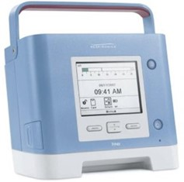

* Pressure Controlled SIMV
* Breath rate: 1 to 60 BPM
* IPAP range: 5 to 50 mbar
* EPAP range: 4 to 25 mbar
* CE-marked.

### SLE2000 infant ventilator

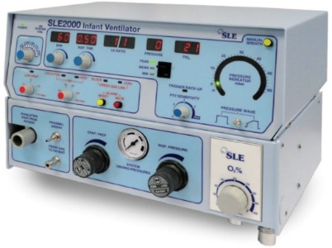

* Pressure Controlled SIMV
* Breath rate: 1 to 125 BPM (varies between markets).
* PIP range: 0 to 60 mbar.
* PEEP range: 0 to 15 mbar.
* CE-marked.
* The SLE2000 functional design has remained unchanged for 30 years and still delivers good patient outcomes.

## MDR classification

The ventilator is summarily conformity assessed to the EU Medical Device Directive and the IEC 60601 (ISO 80601) series of standards on basic safety and essential performance. However, due to the urgency in the market requirement, the ventilator is not CE-marked. When CE-marking process completes, the ventilator would become **Class IIb** and the full conformity assessment to this class would be performed.

## User responsibility

The ventilator and the accessories for it are designed for use in accordance with the displayed labels and supplied instructions. User must be suitably, clinically trained and authorised by their clinical management to operate the ventilator. Oxygen is a drug and should be prescribed as such.

The equipment and gas supply hoses must be periodically checked, maintained and components repaired and replaced, when necessary, for the equipment to operate safely and reliably.

Parts that have failed, in whole or in part, or exhibit excessive wear, or are contaminated, or are otherwise at the end of their useful life, should not be used and must be replaced immediately with approved parts.

The use of oxygen requires generalised precaution to avoid fire hazards, including that sources of ignition are kept away when oxygen is in use. High-pressure oxygen fittings must not be oiled or greased.

# Device application context

The COVID-19 coronavirus pandemic is in April 2020 an ongoing health emergency across the world. Governments report that existing ventilators stock are insufficient to meet the crisis demand. In Europe, the ventilators provision is approximately 1 ventilator per 10,000 head of population. The demand from the pandemic requires this provision to be increase to about 1 in 2,000, which equates to about 4,000 additional ventilators per 10 million population. Practically every country in the northern hemisphere has a similar situation, meaning that there is very little scope for inter-nations support. Each country must largely source its solutions from within its own nation.

Obtaining thousands of ventilators in 6 weeks is just the basis for meeting the needs. The hospitals system says it can probably double the number of intensive care unit (ICU) beds within pre-existing facilities. Existing suppliers of advanced ICU ventilators are expected to fill this demand. Together, this meets 25% of the additional demand.

This leaves 75% of respiratory care patients to be treated in facilities that are yet to be established, using equipment that is yet to be established.

Not all respiratory care patients require an advanced ventilator. Experiences from Italy reports that up to 50% of respiratory care patients can be sustained using CPAP, preventing them deteriorating into respiratory distress. CPAP devices are comparatively quick to produce. The F1 motor racing industry, steered by Mercedes, have for example committed to producing 1,000 CPAP drivers per day. Production of the plastic consumables are being ramped up accordingly.

This still leaves 25% of the additional patients in need of a respiratory care device, which features functionality somewhere between the CPAP device and an advanced ICU ventilator.

Once the healthcare system is forced to turn warehouses into makeshift intensive care wards, as the images seen from Italy, then each ‘ward’ will feature the following characteristics:

* Hundreds of patients, tightly organised.
* Rudimentary infrastructure – probably mobile compressors and restricted use oxygen bottles.
* Healthcare staff with below average respiratory care skills, and very tired/overworked.

This is not a realistic environment for an advanced skills and infrastructure demanding ICU ventilator. It is also not an environment for a single limb homecare ventilator, which exhausts contaminants into the ambient environment and places the healthcare personnel at significant risk from cross-contamination. Off-course, we have reached emergency conditions and compromises must be made. One branch of the UK Government has, for example, has specified a ventilators that requires no more than 30 minutes training time per each staff. The situation demands a simplified approach.

Health services across the world are procuring ventilators. It is observed that many procurement specifications have requested Volume Control ventilation. Real-time breath volume measurement technology is relatively complex to implement (compared to pressure measurement). It demands components and sensors with very fine manufacturing tolerances, available from a limited number of global suppliers. The blending of air and oxygen, into a medical gas, is another feature that adds to a component count that is in short supply or currently cannot easily be shipped across the world.

It must also be remembered that the emergency ventilators will be operated by non-expert personnel, who will find the complexity of Volume Control unmanageable – both therapeutically and technically. Simpler Pressure Control ventilators of the past have delivered, and are still delivering, a valuable level of therapy – without Volume Control. Pressure Control ventilation can offer a better match for the conditions in the makeshift ward.

It is also observed that some health services are specifying that emergency ventilators should display both the control settings and the monitored values of these settings. For example, the emergency ventilator should display both the set PEEP (Peak End Expiratory Pressure) and the actually measured PEEP. Again, it must be remembered that the emergency ventilators will be operated by non-expert personnel. Respiratory ventilation is an output-based therapy. It is meaningless to treat a patient by the input parameters. These are the mere starting point, because a set of input parameters will produce different results for different patients, and they might well produce different results for the same patient at different times (as the diseased lung changes).

Displaying both the set and monitored input parameters will add an unnecessary (valueless) layer of complexity for the non-expert operator. The make-shift ward demands simplification – not complication. The simplified ventilator should instead just show the essential control settings, but monitor in the background that these are being achieved – and alarm if they are not. If the ventilator control settings are shown and the monitor does not alarm, then it evidences that the settings are achieved (within tolerances).

It is well documented (although the profession does not always like to admit it) that putting a low-tech ventilator in the hands of a highly skilled respiratory therapist, can achieve a better patient outcome than putting a high-tech ventilator in the hands of a lesser skilled respiratory therapist. Patient outcomes depends more on the clinical skills and procedures, than on the technology. The simplification and lacking functionality have potential for slightly decreasing the clinical efficacy; but this is easily outweighed by the benefits from having a device that the lesser skilled clinicians are comfortable operating.